
SRM Institute of Science and Technology
Mode of Exam
OFFLINE
College of Engineering and Technology
SCHOOL OF COMPUTING
SRM Nagar, Kattankulathur – 603203, Chengalpattu District, Tamilnadu
Academic Year: 2022-23 (EVEN) SET-A
Test: CLAT-1 Date: 17.2.2023
Course Code & Title: 18CSC304J -COMPILER DESIGN Duration: 1 HOUR
Year & Sem: III & VI Max. Marks: 25

Course Articulation Matrix:
S.No. | Course Outcome | PO1 | PO2 | PO3 | PO4 | PO5 | PO6 | PO7 | PO8 | PO9 | PO10 | PO11 | PO12
1 | CO1 | 3 | 3 | 3

Part – A ( 5 x 1 = 5 Marks)
Instructions: Answer ALL
Q. No | Question | Marks | BL | CO | PO | PI Code
1 | The regular expression (0|1)*(0|1) represents a language with  - Nonempty binary strings  - Empty and nonempty binary strings  - Odd nonempty strings  - Even nonempty strings  Answer: a | 1 | 2 | 1 | 1 | 1.4.1
2 | The total number of states to build the given language using DFA: L={w|w has exactly 2 a’s and at least 2 b’s}  - 10 b) 11 c)12 d)13  Answr\]er: a | 1 | 3 | 1 | 2 | 2.1.3
3 | Which of the following is not a regular expression?  a) [(a+b)*-(aa+bb)]*  b) [(0+1)-(0b+a1)*(a+b)]*  c) (01+11+10)*  d) (1+2+0)*(1+2)*  Answer: b | 1 | 2 | 1 | 2 | 2.1.2
4 | Regular expression Φ* is equivalent to  a) ϵ b) Φ c) 0 d) 1  Answer :a | 1 | 1 | 1 | 1 | 1.2.1
5 | ________________takes collection of rules that define the translation of each operation of the intermediate language into the machine language for the target machine.  - Parser generators  - Scanner generators  - Syntax-directed translation engines  - Automatic code generators  Answer : D | 1 | 1 | 1 | 1 | 1.3.1
Part – B ( 2 x 4 = 8 Marks)
Instructions: Answer any TWO
6 | The two tests schemes can be reduced to one in input buffering technique? justify your answer with an algorithm.  The two tests can be reduced to one, if each buffer half holds a sentinel character at the end.  The sentinel is a special character of eof.  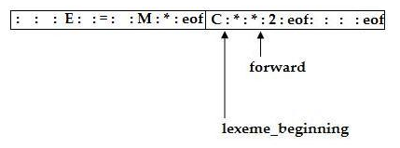  forward := forward + 1’  if forward = eof then begin  if forward at end of first half then begin  reload second half;  forward := forward + 1  end  else if forward at end of second half then begin  reload first half;  move forward to beginning of first half  end  else  terminate lexical analysis  end | 4 | 1 | 1 | 1 | 1.3.1
7 | Construct a syntax tree with firstpos and lastpos for all nodes of (a|b)*abb.  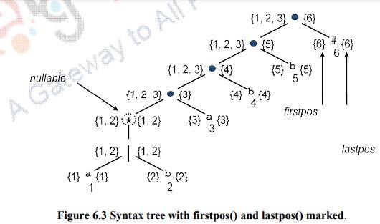 | 4 | 2 | 1 | 2 | 2.3.1
8 | Construct the minimal DFA for the below diagram.  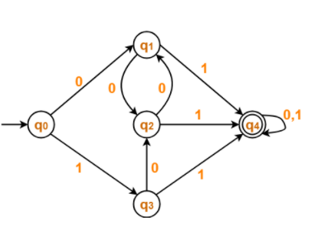  Answer  First Construct Transition table for the given diagram  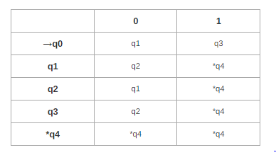  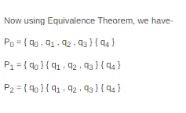  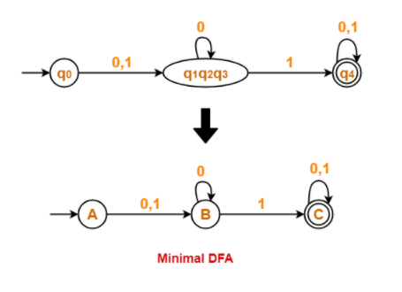 | 4 | 3 | 1 | 2 | 2.3.1
Part – C ( 1 x 12 = 12 Marks)
Instructions: Answer any ONE
9 | (i). Consider the input c=a+b*5. With a neat sketch, illustrate how the input is transformed into assembly code, using all the phases of compiler.  (Problem solving-4 marks, explanation-4)  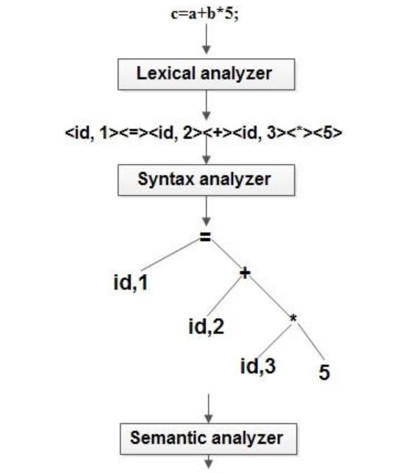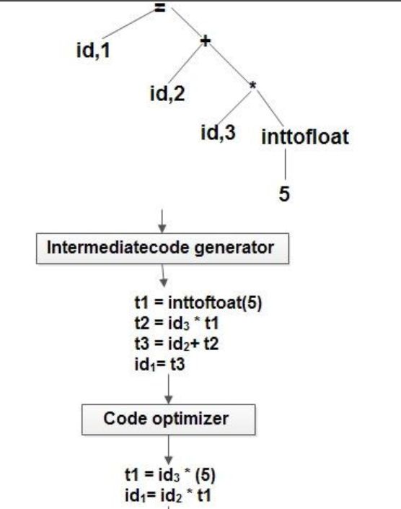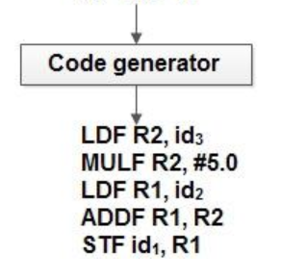  (ii). Illustrate LEX code with an example.  Answer:  %{  #include <stdio.h>  #include "y.tab.h"  int c;  extern int yylval;  %}  %%  " " ;  [a-z] {  c = yytext[0];  yylval = c - 'a';  return(LETTER);  }  [0-9] {  c = yytext[0];  yylval = c - '0';  return(DIGIT);  }  [^a-z0-9\b] {  c = yytext[0];  return(c);  } | 8  4 | 2 | 1 | 2 | 2.2.1
OR
10 | (i). Convert the following Non-Deterministic Finite Automata (NFA) to Deterministic Finite Automata (DFA) using subset construction method.  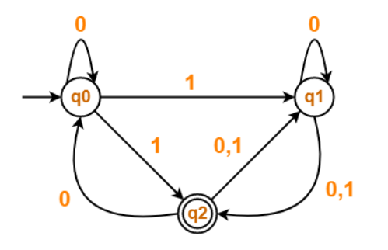  Answer : Accept any method of conversion for this question                              (ii). Inference the importance of the compiler construction tools  Answer :  Some commonly used compiler-construction tools. include  1. Parser generators.  2. Scanner generators.  3. Syntax-directed translation engines.  4. Automatic code generators.  5. Data-flow analysis engines.  6. Compiler-construction toolkits.  Parser Generators  Input: Grammatical description of a programming language  Output: Syntax analyzers.  Parser generator takes the grammatical description of a programming language and produces a syntax analyzer.  Scanner Generators  Input: Regular expression description of the tokens of a language  Output: Lexical analyzers.  Scanner generator generates lexical analyzers from a regular expression description of the tokens of a language.  Syntax-directed Translation Engines  Input: Parse tree.  Output: Intermediate code.  Syntax-directed translation engines produce collections of routines that walk a parse tree and generates intermediate code.  Automatic Code Generators  Input: Intermediate language.  Output: Machine language.  Code-generator takes a collection of rules that define the translation of each operation of the intermediate language into the machine language for a target machine.  Data-flow Analysis Engines  Data-flow analysis engine gathers the information, that is, the values transmitted from one part of a program to each of the other parts. Data-flow analysis is a key part of code optimization.  Compiler Construction Toolkits  The toolkits provide integrated set of routines for various phases of compiler. Compiler construction toolkits provide an integrated set of routines for construction of phases of compiler. | 8  4 | 3 | 1 | 3 | 3.3.2

*Performance Indicators are available separately for Computer Science and Engineering in AICTE examination reforms policy.

Course Outcome (CO) and Bloom’s level (BL) Coverage in Questions

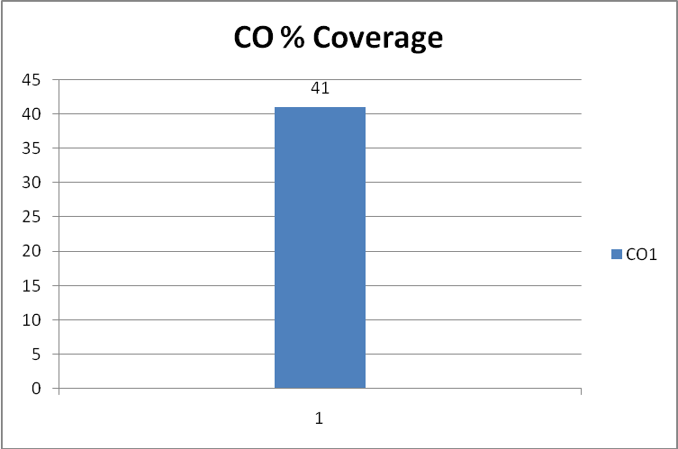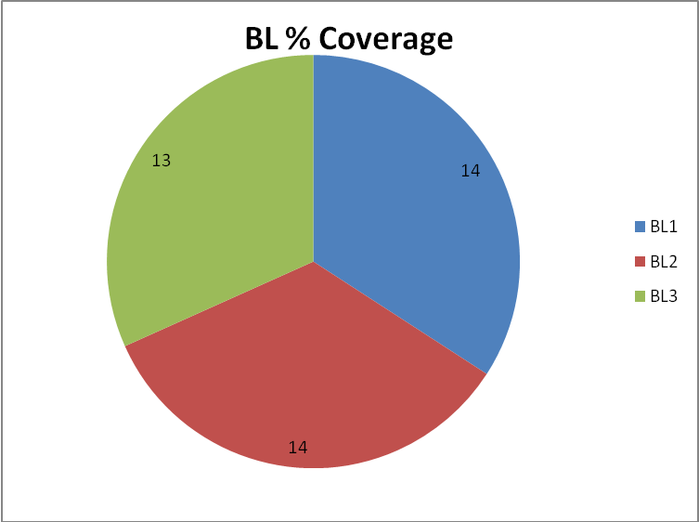

Approved by the Audit Professor/Course Coordinator

